Understanding Coding
Course Code and title | Understanding Coding (Python)
Units Covered | Python
Task Title | Guess My Number
Author | Komal Karir
Date Issued | 1st September 2025
Date Due | 5th September 2025

Learner’s Statement
All work submitted in your portfolio must be your own.

If you copy from AI tools, somebody else or allow another candidate to copy from you then you may be disqualified.

I have read and understood the Notice for Candidates

I confirm:

- This submission is my own work
b) Any help from others, excluding the tutor(s), has been explained below.

Learner’s Name: | Michael Everett
Date Submitted

Python Code: Please paste your Python code in the box below.
# Paste your code here
# ==================================================
# Guess my number game
# NCFE Level 2 certificate homework
# Michael Everett
# ==================================================

import random as rd

welcomeMessage = "Welcome to my random number guessing game! Please guess a number between 1 and 99 to begin. You get 10 guesses in total! Good luck."

print(f"{welcomeMessage}\n{40 * '='}")

def guessingGame() :

userGuessInput = int(input("Please guess a number between 1 and 99. "))
numOfGuess = 1
randomNumber = rd.randint(1, 99)

while userGuessInput != randomNumber :

playAgain = ()

if numOfGuess == 10 :
print(f"{40 * '-'}\nUnlucky! You were unable to guess the number this time, which was {randomNumber}. Better luck next time!")

playAgain = input(f"{40 * '-'}\nWould you like to try again? y/n: ")

if playAgain == "y" :
guessingGame()

elif playAgain == "n" :
print("Ok! Thank you for playing.")
break

else :
playAgain = input("Invalid input, please enter y or n: ")

elif numOfGuess <= 10 and userGuessInput < randomNumber :

numOfGuess += 1
userGuessInput = int(input(f"{40 * '-'}\nNot quite! Your guess is too small. Try again! You have {11 - numOfGuess} guesses remaining. "))

elif numOfGuess <= 10 and userGuessInput > randomNumber :

numOfGuess += 1
userGuessInput = int(input(f"{40 * '-'}\nNot quite! Your guess is too big. Try again! You have {11 - numOfGuess} guesses remaining. "))

else :

playAgain = input(f"{40 * '-'}\nWow! You were able to guess the number {randomNumber} in {numOfGuess} attempts! Nice going. Play again? y/n: ")

if playAgain == "y" :
guessingGame()

elif playAgain == "n" :
print("Ok! Thank you for playing.")

else :
playAgain = input("Invalid input, please enter y or n: ")

guessingGame()

Evdence of Testing

Please paste screen shots or screen snippets as evidence of testing and test results.

Include comments to describe the screen image.

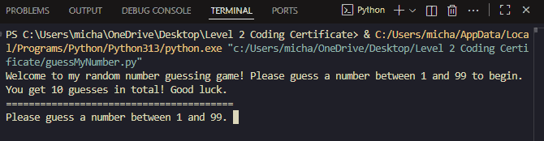
Initial screen:

First guess (too big):

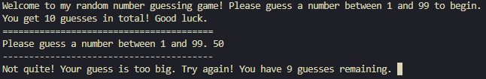

Second guess (too small):

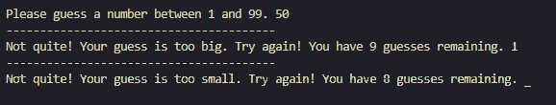

Successful guess in 5 attempts:
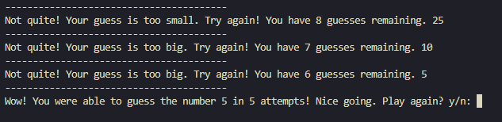

Playing again:

Unable to guess within 10 attempts:

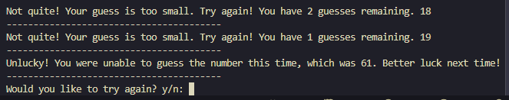
Not playing again:

